Installing App on vps server.

1. Clone app from [git@github.com:villagescc/villages-mern.git](mailto:git@github.com:villagescc/villages-mern.git) on vps

git clone [git@github.com:villagescc/villages-mern.git](mailto:git@github.com:villagescc/villages-mern.git)

1. Installing MongoDB and Configuring.  
   You don’t have to install MongoDB.  
   This App uses Mongo Atlas API.
2. Install Node.js.
3. Setup PM2 to run React in frontend, Node.js in backend.

sudo npm install –g pm2

* 1. Navigate to Backend Directory

cd ~/backend

pm2 start npm –name “backend” start

pm2 startup

pm2 save

* 1. Navigate to Frontend Directory

cd ~/frontend

pm2 start npm –name “frontend” run serve –s build

pm2 startup

pm2 save

1. Install Nginx and Configure it.

Install Nginx

sudo apt install nginx

Remove default configurations

sudo rm /etc/nginx/sites-available/default

sudo rm /etc/nginx/sites-enabled/default

Create new Nginx configuration

Paste the following. In this configuration we are pointing the main domain path to the build output directory of React.js application and the /api path for the Express.js application.

sudo nano /etc/nginx/sites-available/villages.io.conf

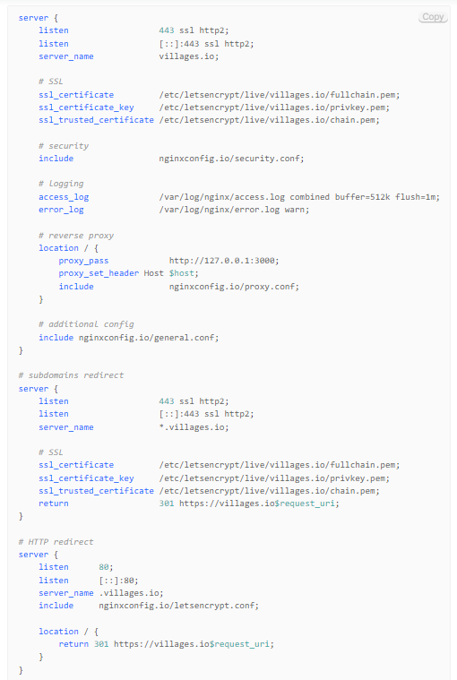

Enable your configuration by creating a symbolic link.

Sudo ln –s /etc/nginx/sites-available/villages.io.conf /etc/nginx/sites-enabled/villages.io.conf

Check your Nginx configuration and restart Nginx

sudo nginx –t

sudo service nginx restart

How to Restart App

pm2 restart backend

pm2 restart frontend

Here there are other pm2 commands for various tasks as well that are pretty self explanatory:

* pm2 show app
* pm2 status
* pm2 restart app
* pm2 stop app
* pm2 logs (Show log stream)
* pm2 flush (Clear logs)

Setup SSL

Install free Let’s Encrypt SSL certificate for domain.

sudo apt install python3-certbot-nginx

Execute the following command to install certificate and configure redirect to HTTPS automatically

sudo certbot –nginx –redirect –agree-tos –no-eff-email –m [info@villages.io](mailto:info@villages.io) –d villages.io –d [www.villages.io](http://www.villages.io)

Now you should receive SSL certificate and it will be configured automatically.

Setup auto renewal

sudo certbot renew –dry-run

Now you can look up your domain in your browser to see the output.